How to Prepare for Jobs that Don’t Exist Yet

The nature of work is changing across the globe. New jobs will emerge in the next decade that didn’t exist 5 years ago, while other jobs will become obsolete. Jobs that will exist in what researchers terms “The Fourth Industrial Revolution” will require new and rapidly changing skill sets. Understanding the changing trends and building strong skill sets that can be easily adapted will be essential to remain valuable in this new employment landscape.
The speed in which business models are changing directly impacts employees and the skills required for them to do their job effectively. As this revolution unfolds at breakneck speed, the necessity for employees to possess new or advanced skills is immediate once these changes take place in their industry. How can employees remain valuable and future-proof their careers in this new revolution?
According to global industry experts with the World Economic Forum, skill sets are changing so rapidly that what may be a requirement today will be archaic in 3 to 5 years: “On average, by 2020, more than a third of the desired core skill sets of most occupations will be comprised of skills that are not yet considered crucial to the job today.” And those skill sets may surprise you. Social skills, such as persuasion and emotional intelligence, will be in high demand. Narrowly defined technical skills, while they may still be needed, must be supplemented with interpersonal skills such as strong social and collaborative skills, say the researchers.
Identifying Skills Gap
The future of the employment landscape will require workers who can provide employers with a broader set of strengths. While most people can easily list their core competencies gained from their education and work experience, identifying other competencies takes some forethought. FlexJobs.com lists 11 skills needed to succeed in the future workforce:
- Social Intelligence: The ability to negotiate and navigate in a complex, connected world.
- Math: Jobs in the STEM sector (science, tech, engineering, math) are increasing, and math is the common denominator. The ability to use math in analytical ways will be essential.
- Cross-Cultural Competency: Job seekers who demonstrate cultural awareness will thrive in the new global economy.
- Innovative and Adaptive Thinking: Are you a creative problem solver? If so, you’ll be poised to thrive.
- Virtual Collaboration Skills: Those who will succeed will possess both independence and a collaborative attitude.
- Design Mind-Set: Thinking outside-the-box with a goal-oriented approach.
- New Media Literacy: Platforms for communicating information will continue to swiftly evolve, and workers who can embrace new media will be in demand.
- Computational Thinking: The influx of big data will require workers with strong data-based cognitive skills.
- Sense Making: Workers with strong critical thinking and reasoning skills will be needed to make sense of the big data.
- Cognitive Load Management: Employers will place a premium on workers who can handle and prioritize tasks and systems based on available data.
- Transdisciplinary Skills: Globalization and large organizations will depend upon those whose skills transfer across multiple areas of expertise.
In addition to these skills, Laurent Haug, contributor for World Economic Forum, believes that empathy, creativity, leadership, intuition and social intelligence are at the top of the needed skills for the future of all industries. “If I were to give younger people an idea of the skills they’ll need,” Haug says, “these would be on the list, as well as advice to pay attention to how machines function and think.” Workers who can analyze data, who can transfer the knowledge of data to solve problems and forecast trends, in addition to possessing essential interpersonal and analytical thinking skills, will be irreplaceable in this new revolution. This requires critical and creative thinkers and strong problem solvers. While technology is driving much of this rapid change, providing human insight is still necessary.
Are You Ready for the Demand?
A changing workplace is already upon us, and industry experts have begun to see a shift in the ease at which they can find qualified employees to meet demand. The chart below shows the average ease of recruitment across industries. In all sectors, experts polled anticipate difficulties hiring.

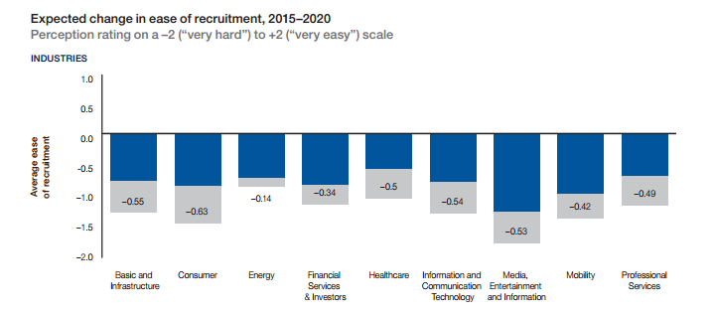
Most of the jobs in these industries are already finding it difficult to keep enough people in the talent pipeline for hiring purposes. In demand sectors such as architecture and engineering, computers and mathematical engineering are already in a fierce battle for qualified applicants, and in the next 3 to 5 years, is only expected to worsen, according to WEF.
Improving Your Skill Set
Researchers with the World Economic Forum believe that aging countries won’t simply need life-long learning, but will require a “wholesale reskilling of existing workforces throughout their lifecycle.” While many workers will need to continually update their skills to keep up with rapid industry changes, those in positions that will eventually become obsolete will need a total re-invention of skills.
To acquire the skill sets needed, those entering the workforce as well as those already in the workforce will have to change the way they think about education. It’s not enough to be a lifelong learner; today’s employment landscape demands workers mount a specific, focused reskilling effort to meet the ongoing needs in their industry. For long- term resilience, workers must have the foresight to determine changes coming to their industry. In the past, employees have relied on their formal training or their employers to determine the skills they need to perform their job. Today’s employees must anticipate the changes in their industry and continually keep ahead of the curve.
Can Soft Skills be Learned?
Gaining highly regarded skills such as communication and analytical thinking are more difficult to learn in a classroom setting, and are simply innate in those who excel at them. But even though these soft skills may be more difficult to learn doesn’t mean it’s impossible to improve on those skills. Improvement takes practice and hard work, but it can be done.
How do you show a potential employer that you have what it takes? While it’s easy to list technical knowledge, experience and training on a resume, demonstrating proficiency with communication skills takes a bit more work. Instead of stating “great oral communication skills,” show how you are great by explaining when you were successful with oral communication. Lily Zhang, Career Development Specialist, suggests to use facts and figures: “Managed strict project timeline successfully by coordinating virtual meeting across time zones and presenting findings to over 50 colleagues via teleconference,” (themuse.com). Provide examples and specifics to demonstrate your strengths to potential employers.
The pace at which this fourth industrial revolution will disrupt business and industry and affect the workers they employ will require targeted action today to build a futureproof workforce. Experts in academia, professional research firms, international organizations and their human resources departments all agree that this rapid transformation is already here and beginning to affect business organizations who are unprepared. While no one can predict the future, today’s young professionals can better prepare themselves for this changing employment landscape by continually building skill sets that will keep them on the path to success and poised for the future.

Sources:
http://reports.weforum.org/future-of-jobs-2016/
https://www.flexjobs.com/blog/post/skills-need-future-workplace/
http://fortune.com/2016/09/01/automation-jobs-robots/
https://www.themuse.com/advice/the-nonboring-way-to-show-off-your-soft-skills-in-your-job-search

